Big Mountain Resort (BM), a ski resort located in Montana, has been charging a premium above the average price of resorts in its market segment. However, there are limitations to this approach. To cover the additional operating cost of the new chair lift we recently installed, we’ve done some analysis on the data of 330 ski resorts (including BM) across the U.S. to provide some guidance on how to capitalize on its facilities as much as it could and how to select a better value for their ticket price in order to increase revenue for the resort.

We built two models, a linear model and a random forest model, to predict the ticket price. We decided to use the latter because it had a lower cross-validation mean absolute error by almost $1. It also exhibited less variability. Verifying performance on the test set produced performance consistent with the cross-validation results. The random forest gave a mean absolute error of 9.64 on the training set and 9.54 on the test set, comparing to the linear model’s 10.50 and 11.79 on the training set and test set, respectively.

It’s worth mentioning that both models showed that the top four features that have the most (positive) influence to the ticket price are vertical drop, snow making area, number of runs, and number of fast quads.

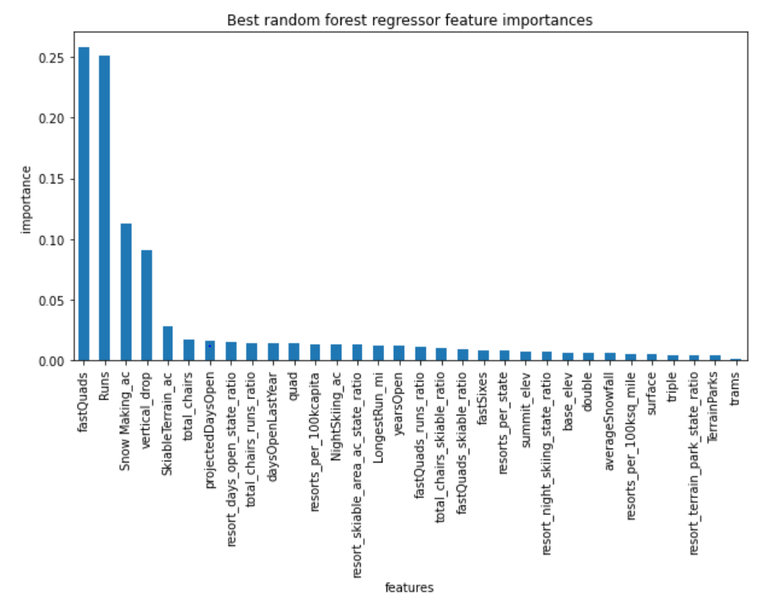

The Big Mountain resort currently charges $81.00 per ticket, while our modelling suggests for a ticket price of $95.87 with the expected mean absolute error of $10.39, so there's room for an increase, and the BM resort seems to be undercharging. However, the validity of our model lies in the assumption that other resorts accurately set their prices according to what the market supports, so we might need some more information to determine whether BM should increase their ticket price or not. To cover the additional operating cost of the new chair lift per ticket, we examined how the ticket price and the revenue would change for each of the four options that the business had shortlisted. For future improvements, I'd recommend considering a combination of scenario 1, which is to permanently close down up to 10 of the least used runs, and scenario 2, which is to increase the vertical drop by adding a run to a point 150 feet lower down but requiring the installation of an additional chair lift to bring skiers back up, without additional snow making coverage.

For scenario 1, there seems to be a strategy when determining how many least used runs to close down. We created two plots using our model, one for the predicted ticket price change for each number of runs closed in the scenario, and one for the associated predicted revenue change on the assumption that each of the expected visitors buys 5 tickets.

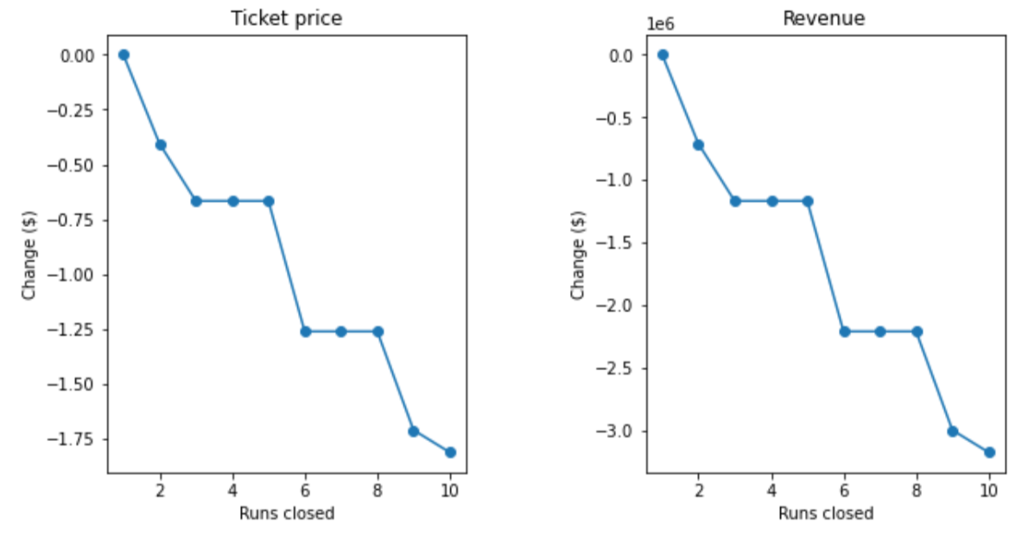

The model says closing one run makes no difference. Closing 2 and 3 successively reduces support for ticket price and so revenue. If BM closes down 3 runs, it seems they may as well close down 4 or 5 as there's no further loss in ticket price. Increasing the closures down to 6 or more leads to a large drop. Of course, we still need to take the reduction of operation cost of runs into account later.

For scenario 2, our model predicts that by adding a run, increasing the vertical drop by 150 feet, and installing an additional chair lift, the modelled ticket price would be increased by $1.99, which could potentially increase revenue by $3474638 on the assumption that each of the expected visitors buys 5 tickets. Again, we will need to take maintenance fee of a run and additional operating cost of the new chair lift into consideration.